Integrate ETM

Version 1.0

SHMT Co., Ltd.

REVISION HISTORY
Version | Detail(굴림/Verdana 10pt bold) | Name | Date
1.0 | First Version | gtlee | 2007-01-05

Technical documents
Copyright © 2006 Shmt Limited. All rights reserved.

Confidentiality Status
This document is NOT OPEN ACCESS. The distribution is restricted to certified company.
This document is CONFIDENTIAL.

Feedback on this document
If you have any comments on this document, please contact your channel to our company.

Shmt Web address
http://www.shmt.com

Contents

Detail contents (굴림/Verdana 12pt bold)
1. Validation Resource 7
1.1. Base Information 7
1.1.1. Base Directory 7
1.1.2. Tools 7
1.2. RTL Sources 7
1.2.1. ARM926EJ-S top files 7
1.2.2. Test Bench files 8
1.3. RTL compile 8
1.3.1. Directory 선택 8
1.3.2. Platform 선택 8
1.3.3. Compile 9
1.4. Validation 9
1.4.1. Configuration File 수정 9
1.4.2. RTL Directory Link 11
1.4.3. Create Job scripts 11
1.4.4. Execution Job script 11

Figures

Figure (굴림/Verdana 12pt bold)
오류! 그림 목차 항목을 찾을 수 없습니다.

Tables
[Table 1] table(굴림/Verdana 12pt bold)
Table 1-1 libraries.vc 예제 7

ETM RTL code

ETMIF

ARM9EJS core와 ETM9과 연결하기 위해 port name을 change.
ARM926EJS 내에 포함되어 있다.

PWRDOWN signal

Figure 1-1 Power Down signal의 활용1
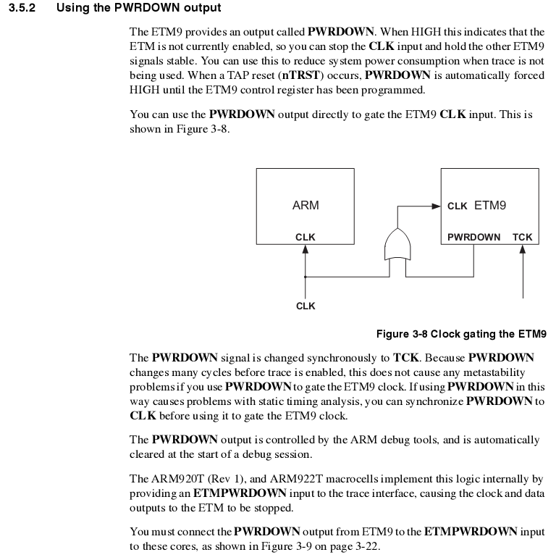

Figure 1-2 Power Down signal의 활용2
